
https://www.mouserecorder.com/:
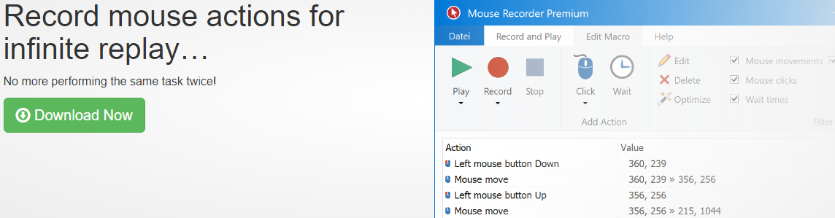
 | Press Record. Perform the actions.  The macro recorder accurately records your mouse movements and clicks

 | Press Stop. Edit the macro.  The built-in macro editor allows you to review your recording and edit the actions.

 | Press Play. Repeat the macro.  Mouse Recorder repeats your macro recording, saving you from repetitive tasks. You can adjust playback speed and smooth out edgy mouse movements on demand.





